Week8_Cleanup and Push to Remote

(GitDemo)

Objective: Clean up and push back to remote Git
Phase 1: Initial Git Configuration
Step 1: Verified Git Version
git version
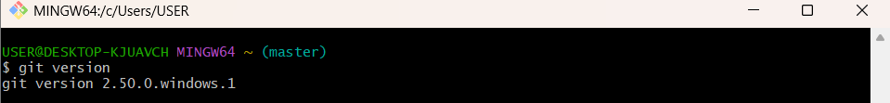
Step 2: Set Your User Name: This name will be associated with your commits.
git config --global user.name https://github.com/SaguturuShruthi
Step 3: Set Your User Name: This email will be linked to your commits.
git config --global user.email krishnashruthi2004@gmail.com
Step 4: Configured User Information
git config --global --list

Phase 2: Environment Setup: Integrating Notepad++
Step 5: Confirmed notepad++ Command Not Found Error
Step 6: Added Notepad++ to Environment Path
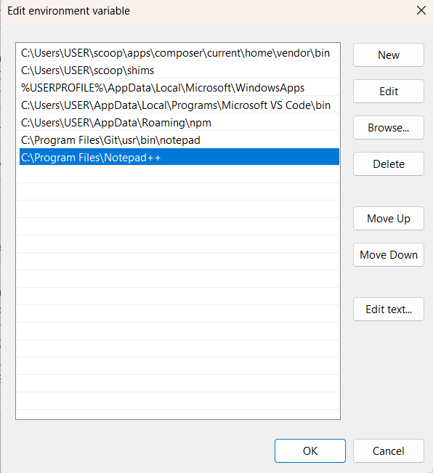
Step 7: Set Notepad++ as Git's Core Editor
git config --global core.editor "notepad++.exe -multiInst -nosession"

Step 8: Verify the Editor Configuration: To confirm the setup, run this command.
git config --global -e
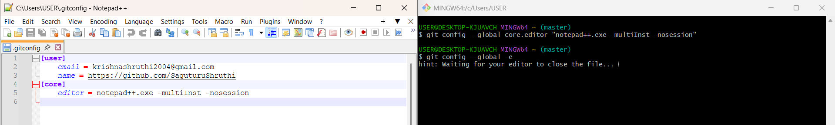
Step 9: Verifying Local Repository State
Ensured the local master branch was in a clean state with no uncommitted changes.
git status
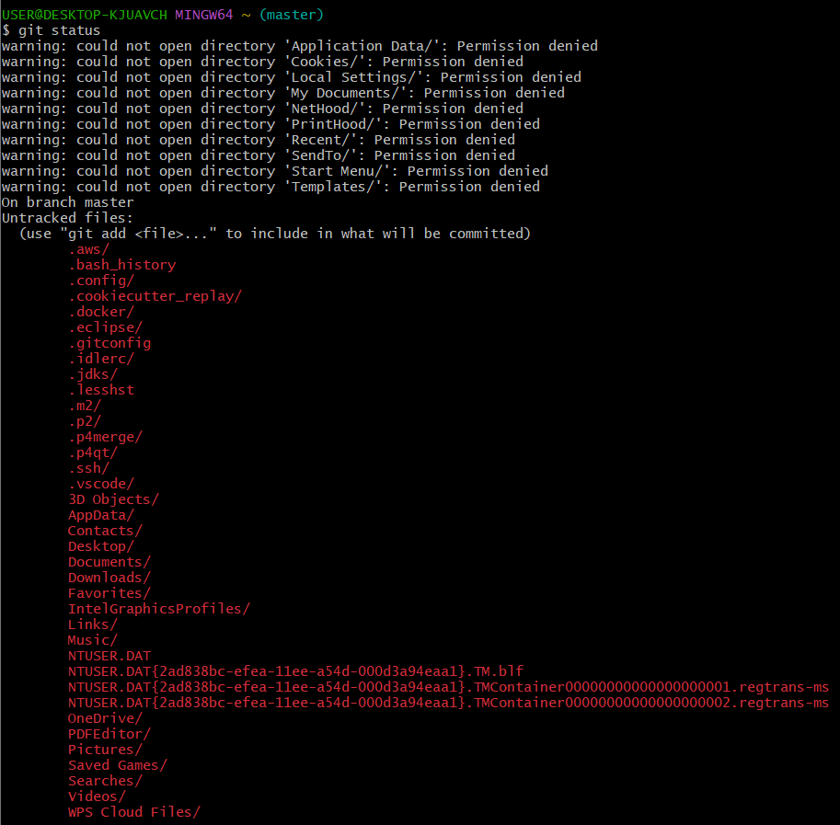
Step 10: Synchronizing with Remote Repository
Pulled from the remote repository to ensure the local branch was up-to-date before pushing.
git pull origin master
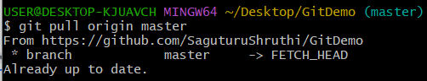
Step 11: Pushing All Changes to GitHub
Pushed all pending local commits (from creating .gitignore, feature.txt, and merging/resolving hello.xml) to the origin remote repository.
git push origin master

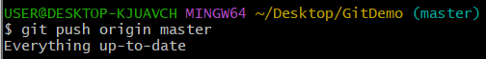
Fiinal Verification:
